First check weather python is properly installed or not then follow the below steps

1. Set up a virtual environment and activate it using the following command.

**python -m venv myenv**

Then activate it by using **myenv\Scripts\activate.bat**

if it is properly created and activated then you should get like this

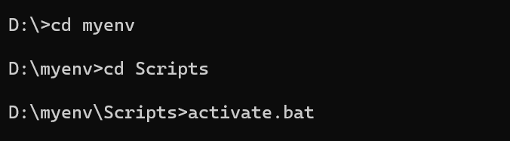

1. Install the required dependencies: Flask, Flask-RESTful, Flask-HTTPAuth and requests. Use the below command to install

**pip install flask flask-restful flask-httpauth requests**

if you get any errors then update your pip version using the below command

**D:\C++\myenv\Scripts\python.exe -m pip install --upgrade pip**

**D:\C++** is my current working directory, you need to use your current working directory

1. Then we need to set TMDb API key as the environment variable **MOVIE_API_ KEY.** Use the below command to set and use the same API key provided here.(I think you need not created new API key)

**set MOVIE_API_KEY=a40501599beaff45356f4f9600fdafd2**

you can check weather it is properly set or not with the command

**echo %MOVIE_API_KEY%**

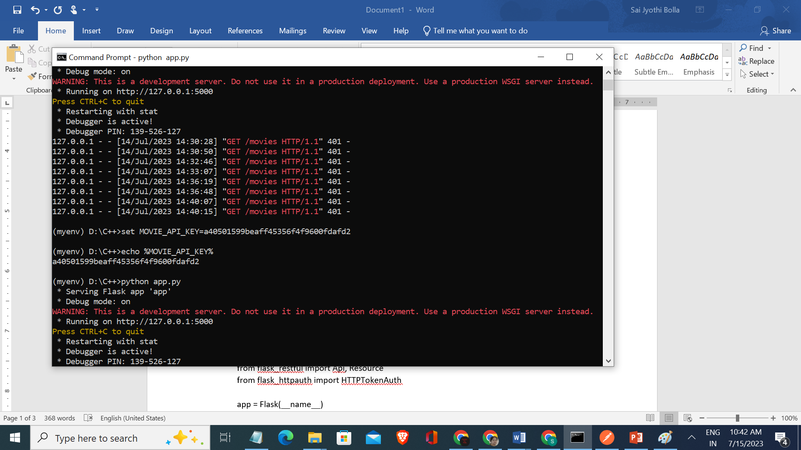

1. **Then save the code as app.py**

import os

import requests

from flask import Flask

from flask_restful import Api, Resource

from flask_httpauth import HTTPTokenAuth

app = Flask(__name__)

api = Api(app)

auth = HTTPTokenAuth(scheme='Bearer')

# Retrieve the API key from environment variable

API_KEY = os.environ.get('MOVIE_API_KEY')

if not API_KEY:

raise ValueError('Movie API key is missing. Set the MOVIE_API_KEY environment variable.')

# Verify the API key

@auth.verify_token

def verify_token(token):

return token == API_KEY

@auth.error_handler

def unauthorized():

return {'message': 'Unauthorized'}, 401

# Endpoint for movie details

class MovieDetails(Resource):

@auth.login_required

def get(self, movie_name):

url = f'https://api.themoviedb.org/3/search/movie?api_key={API_KEY}&query={movie_name}'

response = requests.get(url)

data = response.json()

if 'results' in data and len(data['results']) > 0:

movie = data['results'][0]

movie_details = {

'title': movie['title'],

'release_year': movie['release_date'].split('-')[0],

'plot': movie['overview'],

'cast': self.get_movie_cast(movie['id']),

'rating': movie['vote_average']

}

return movie_details

else:

return {'message': 'Movie not found'}, 404

def get_movie_cast(self, movie_id):

url = f'https://api.themoviedb.org/3/movie/{movie_id}/credits?api_key={API_KEY}'

response = requests.get(url)

data = response.json()

cast = []

if 'cast' in data:

for actor in data['cast'][:5]:

cast.append(actor['name'])

return cast

# Endpoint for movie list

class MovieList(Resource):

@auth.login_required

def get(self):

url = f'https://api.themoviedb.org/3/discover/movie?api_key={API_KEY}&sort_by=popularity.desc'

response = requests.get(url)

data = response.json()

movie_list = []

if 'results' in data:

for movie in data['results'][:10]:

movie_list.append(movie['title'])

return {'movies': movie_list}

# Add routes to the Flask application

api.add_resource(MovieDetails, '/movies/<string:movie_name>')

api.add_resource(MovieList, '/movies')

if __name__ == '__main__':

app.run(debug=True)

1. Then run the program using

**python app.py**

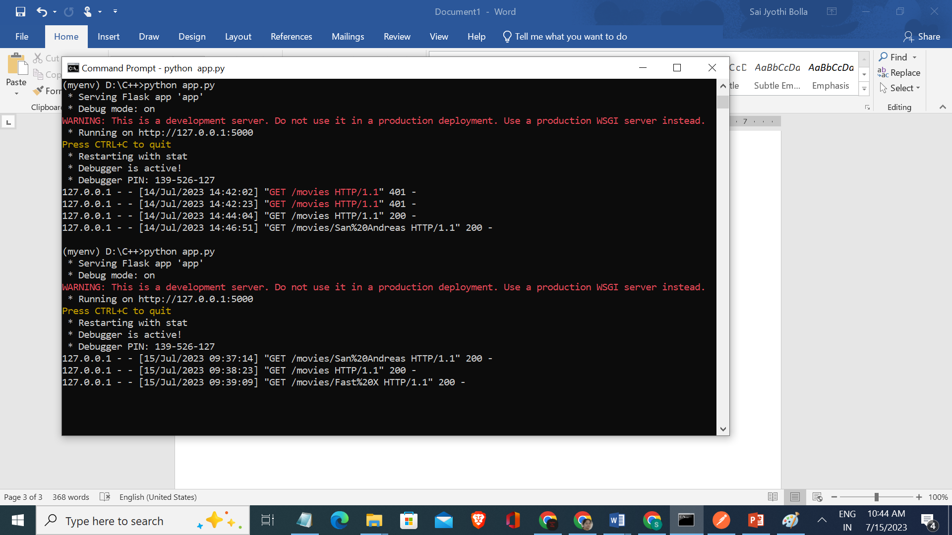

1. After this we need to test it with postman. Open the postman do the following.
2. Select new tab at top left corner
3. select GET request
4. select authorization tab, then from the dropdown select bearer token give the above API key
5. use [**http://127.0.0.1:5000/movies**](http://127.0.0.1:5000/movies) **in get request, now you will get all the moies**

if you want get a specific movie details, you can use http://127.0.0.1:5000/movies/John Wick: Chapter 4.

Here John Wick: Chapter 4 is the movie name.

